Use of forecasting models for improved PID control in wastewater treatment

Kathryn B. Newhart

Table of Contents

Introduction 1

Control in wastewater treatment 2

Methods and Materials 3

Boulder Water Resource Recovery Facility 3

Stability assessment 4

Ammonia forecast 4

Dataset alignment 4

Diurnal model 5

Machine learning 5

Results 6

Stability assessment 6

Ammonia forecast 6

Diurnal model 6

Linear model 7

Appendix 8

Timeseries 8

# Introduction

One of the greatest and costliest threats to surface waterways in the United States is nutrient pollution (Environmental Protection Agency) 2011). The removal of nitrogen and phosphorus from municipal wastewater treatment plant (WWTP) discharges is necessary to address the growing environmental challenge of increased nitrogen and phosphorus. As states implement increasingly stringint nutrient limits on WWTP, the cost of wastewater treatment is increasing substancially. For example, biological removal of nitrogen and phosphorus is acheived by introducing dissolved oxygen (DO) via industrial-sized air blowers, which is one of the largest operating costs in WWTP. Conventionally, air blower speed is increased or decreased relative to the measured concentration of DO in an aeration basin. While this approach can guarentee that nitrogen is removed (i.e., converted from ammonia and other organic nitrogen species to nitrate, and in a subsequent step nitrogen gas), it is inefficient as aeration is provided whether ammonia is present or absent. In the absence of ammonia, air blowers are wasting energy. Additionally, controlling air blower speed by DO does not precisely control the ammonia concentration in the effluent. WWTP operators rely on trial-and-error to identify a DO setpoint that treats water to an ammonia concentration well below their permited limit. The large factor of safety is required to ensure that even under the highest flow and load conditions, the WWTP will not exceed their nitrogen limit. To save energy and reduce excessive use of air blowers at WWTP, a new aeration paradigm is needed.

Ammonia-based aeration control (ABAC) is an aeration approach which responds to water quality changes in real time by adjusting air flow to meet an ammonia setpoint, instead of a DO setpoint. ABAC can limit aeration, to prevent complete ammonia conversion, increase nitrate conversion, and potentially improve phosphorus removal, and reduce effluent ammonia peaks (Rieger et al. 2012).

The most frquently used ABAC configuration utilizes a microbial kinetic model to calculate the aeration demand given a variety of operating parameters such as solids retention time and influent ammonia concentration (Duffy et al. 2010). This feedforward approach requires entensive sampling and specialized knowledge for accurate model calibration. A feedback ABAC option would not require a kinetic model, and simply adjust DO setpoints from an ammonia sensor in the aeration basin. However, WWTP operators can be hesitent to adopt ABAC due to the instability of ABAC sensors (specifically ion-selective electrodes) and the potential for the growth of microorganisms that inhibit settling in subsequent treatment at lower DO concentrations.

The goal of this work is to (1) demonstrate the stability of a feedback ABAC configuration for WWTP operators and (2) explore data-driven methods of forecasting ammonia to overcome the lag associated with conventional feedback control to *improve accuracy* and *reduce mechanical wear* of aeration systems. Four different cascade control aeration configurations are compared to identify the *most stable* (i.e., least variable) operating condition–this will assist WWTP operators in maintaining a low concentration of ammonia in the treated water and test the robustness of forecasting methods. The advantages of forecasting using statistical and machine learning models is (a) no additional sampling, microbiological analysis, or proprietary software is requried to build the model and (b) the forecast can easily replace the current measured value of ammonia in the supervisory control and data aquisition (SCADA) system of the WWTP–which lacks advanced control schema. The manuscript is organized as follows: (1) an introduction to control systems in WWTP, (2) summary of methods for quantifying variation in multivariate systems, (3) summary of staistical and machine learning methods used to build the ammonia forecasting models, and (4) an assessment of how forecasting models can improve conventional control in WWTP.

## Control in wastewater treatment

WWTP are similar to other industrial processes in that select monitored system parameters need to be within a set range for the system to operate properly. Unlike many industrial processes, municipal WWTP have little control over the quantity and quality of the inputs to their system but are required by law to maintain a certain quality of the output. Due to the wide variation, manual adjustments of an open-loop control system (i.e., constant control output regardless of system conditions) cannot constantly achieve the level of treatment needed; frequently under-treating during peak flows and potentially exceeding regulated quality limits, and over-treating during low flows which wastes energy and other material inputs. Therefore, a flexible and responsive control system is required to maintain effluent water quality while minimizing energy and chemical input.

Feedback control determines a control action from a process measurement within the system (i.e., closed-loop control), and is able to automatically respond to system disturbances without specific knowledge of how the control and response parameters are related. The Proprotional-Integral-Derivative (PID) controller is the most common feedback controller in industrial automation due to it’s simplisity and robustness to respond to a deviation from desired conditions (i.e., error ). A PID control action is the sum of: a proportional term () where is a constant value; a integral term () and incorporates past control error with the integral function; and a derivative term () which anticipates future error with the derivative function. In the wastewater treatment industry, the derivative term is frequently set to 0 (i.e., PI control) due to the amplification of noise in the measured variable (Visioli 2006).

A single PID control loop can address straightforward problems, such as adjusting the speed of a blower or pump relative to a sensor measurement. To address more complex, nonlinear problems, multiple PID control loops can be combined in series to form a cascade control structure(Brosilow and Joseph 2002). In the case of ABAC, an ammonia sensor and setpoint define the outer/master control loop while inner/slave control loops define control variables such as DO, air blower flow, air blower speed, etc. In controller design, actuator and sensor dynamics and wear-and-tear are frequently ignored (Visioli 2006). For aeration at WWTP, this leads to a delay between a change in demand and the aeration provided, and excessive ramping of the air blower as a result of the delay.

# Methods and Materials

## Boulder Water Resource Recovery Facility

The Boulder Water Resource Recovery Facility (BWRRF, Boulder, Colorado, USA) is a 25 million gallon per day (MGD) municipal WWTP, currently operating at an average of 12 MGD. Given the high altitude of the facility and low daily ammonia limits (>1.9 mg/L NH4 as N), oxygen transfer efficiency is relatively low and results in high aeration demand (Burger et al. 2019). Subsequently, aeration accounts for 35 to 50% of BWRRF’s energy consumption. There are multiple aeration control methods programmed into the supervisory control and data aquisition (SCADA) system, all of which rely on cascade control: airflow, DO, and ABAC. Airflow produces a constant volume of air by adjusting valves at the inlet of the aeration basin, regardless of the air demand; DO adjusts the volume of air to acheive a DO setpoint; and ABAC adjusts DO setpoints to acheive an ammonia setpoint ()

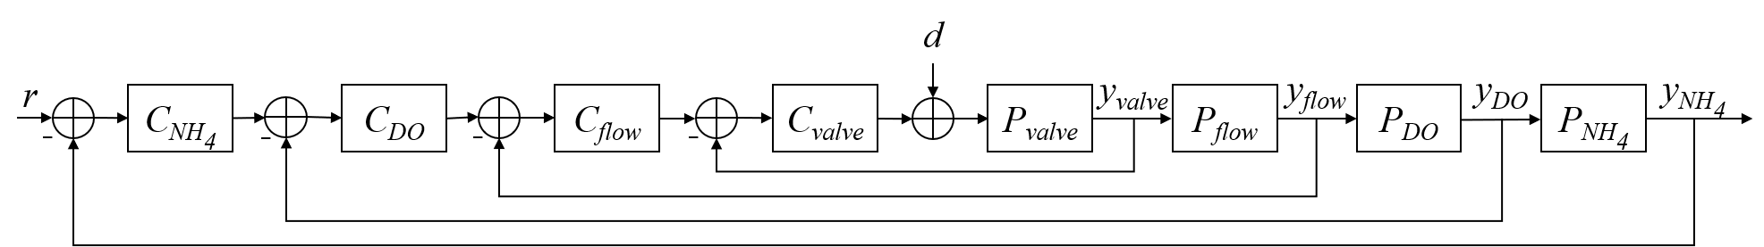

Figure 1. Flow, zone, and sensor diagram of one of the activated sludge aeration basins at the Boulder Water Resource Reclaimation Facility.

2

SCADA has multiple aeration control modes Airflow Dissolved oxygen (DO) Ammonia-based aeration control (ABAC)

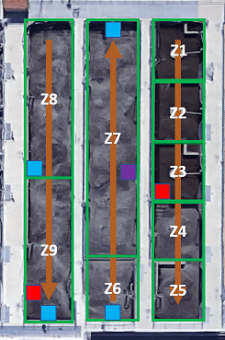

Figure 2. Flow, zone, and sensor diagram of one of the activated sludge aeration basins at the Boulder Water Resource Reclaimation Facility.

* DO and ABAC configurations
* Insert figure of zones

The data compiled for the following analysis can be found in the Appendix. All data was scaled to zero mean and unit variance for each control configuration.

## Stability assessment

* Total sample variance
* Generalized sample variance

## Ammonia forecast

* Training and testing datasets
* Measure model fit/accuracy

### Dataset alignment

To train and test the forecasting model, the data must be aligned to simulate real-time prediction. For a dataset with *n* rows, observations ) of all monitored process variables () will be merged with ( observations of the forecasted variable to create a matrix with columns and rows.

### Diurnal model

The purpose of incorporating a diurnal component into a forecasting model is to capture the time-dependent component of the response variable, in this case ammonia. While the daily trend of ammonia loading to a wastewater facility is acknowledged, it is rarely modeled (Figure 1). The predictors in a diurnal model are various degrees (*n*) of sine and cosine functions where *t* is the minute of the day from 0 - 2, and are fitted linear model parameters:

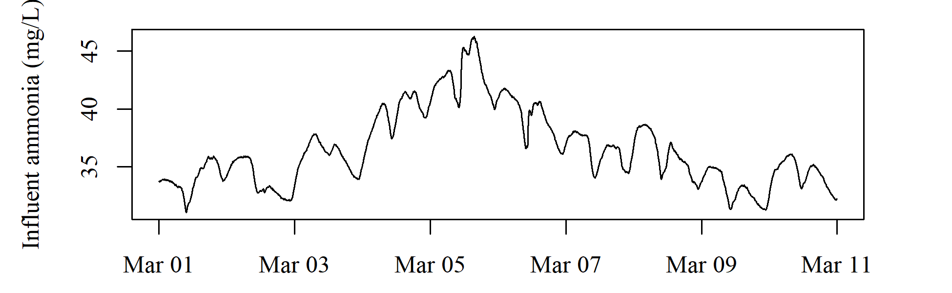

Figure 2: Timeseries plot of influent ammonia at the Boulder Water Resource Recovery Facility.

#### Linear model

In a standard linear model, a response () is described using a set of predictor variables () and their corresponding model parameters where is an error term:

Typical linear models are fit using oridinary least squares, but prediction accuracy and model interpretabililty can be improved using alterntive fitting procedures (James et al. 2013).

Lasso is able to select model predictors (inputs). Ridge regression attempts to minimize the error of predictors while simultaneously eliminating insignificant predictors. The ‘shrinkage’ term responsible for driving the coefficients of insigificant predictors to zero is controled by . When , ridge regression returns the same linear model coefficients as the more well-known ordinary least squares model. Cross-validation Adaptive lasso Both the diurnal model and linear model were trained and tested using the glmnet package.

### Machine learning

* Neural network model

# Results

## Stability assessment

## Ammonia forecast

### Diurnal model

The initial diurnal model fit used a single sine/cosine pair. However, this approach did not capture all visible cyclic patterns. Further testing evaluated the model fit of 1 - 200 sine/cosine pairs. The best diurnal model fit for the training and testing data of each control congiuration was effectively achieved using a 6 degree diurnal model (Figure 2). The realively low R2 value of the ABAC 3.5 control configuration is evident of abnormal variation in the minimum and maximum ammonia values (Figure 3).

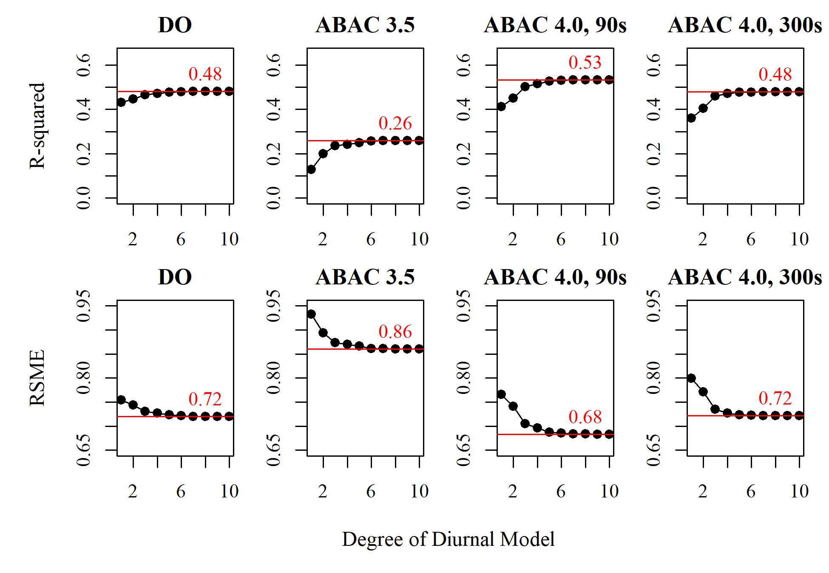

Figure 3: Diurnal model fit as function of degree for each control configuration. The red line indicates the R2 (top) or RMSE (bottom) value for a 10th degree diurnal model, which is effectively achieved by a 6 degree or fewer diurnal model.

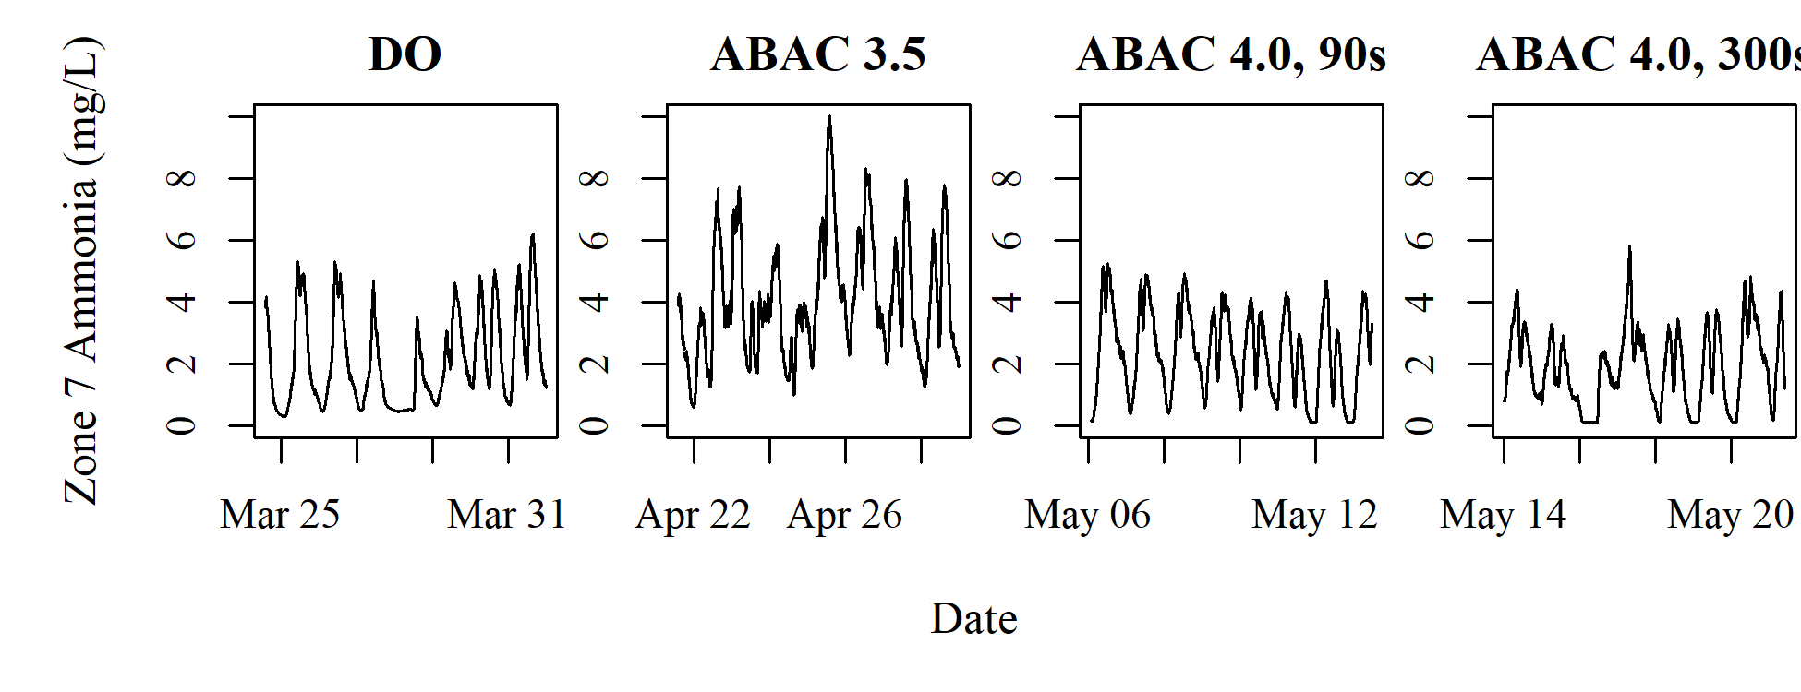

Figure 4: Timeseries plot of zone 7 ammonia at the Boulder Water Resource Recovery Facility.

### Linear model

The remaining variation is modeled using a multiple linear regression model.

# Appendix

## Timeseries

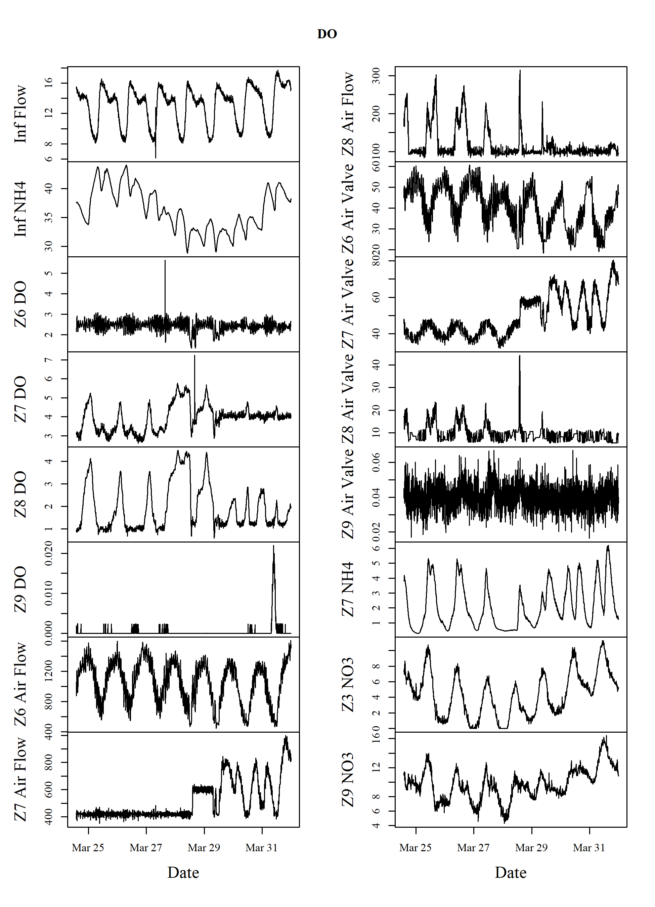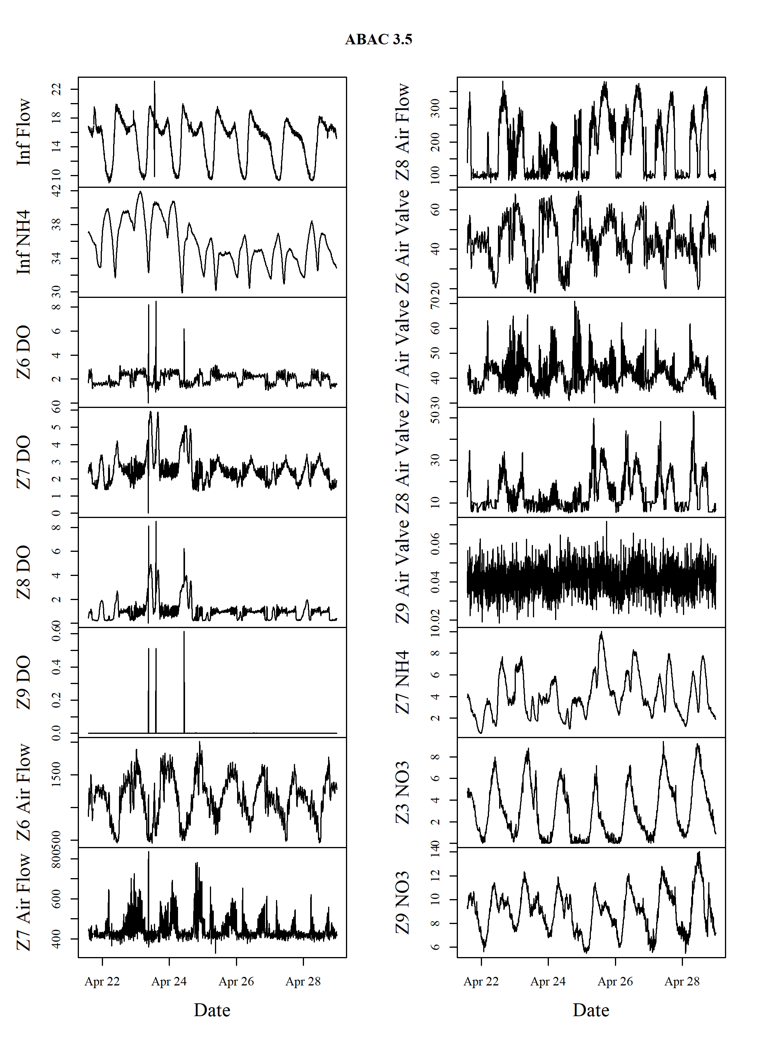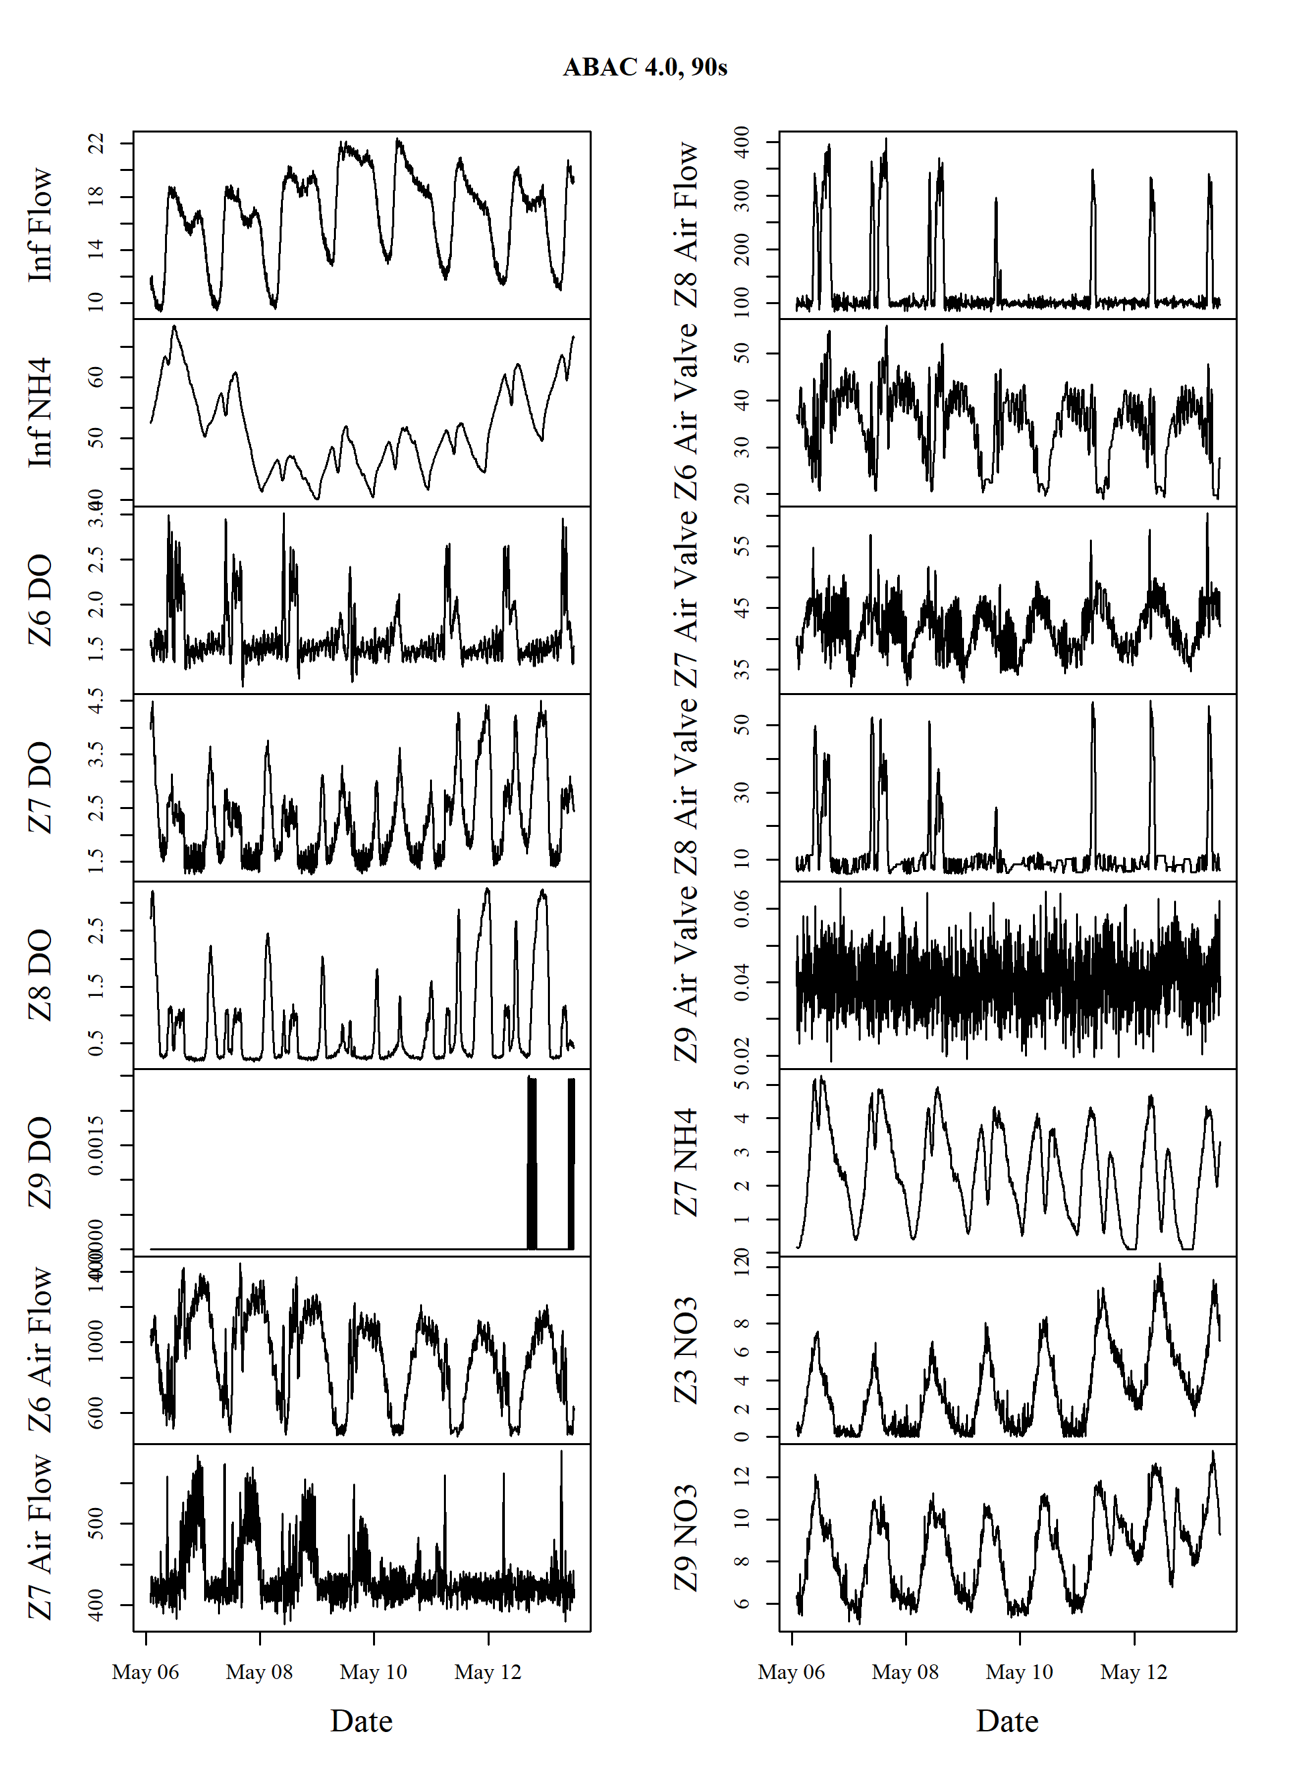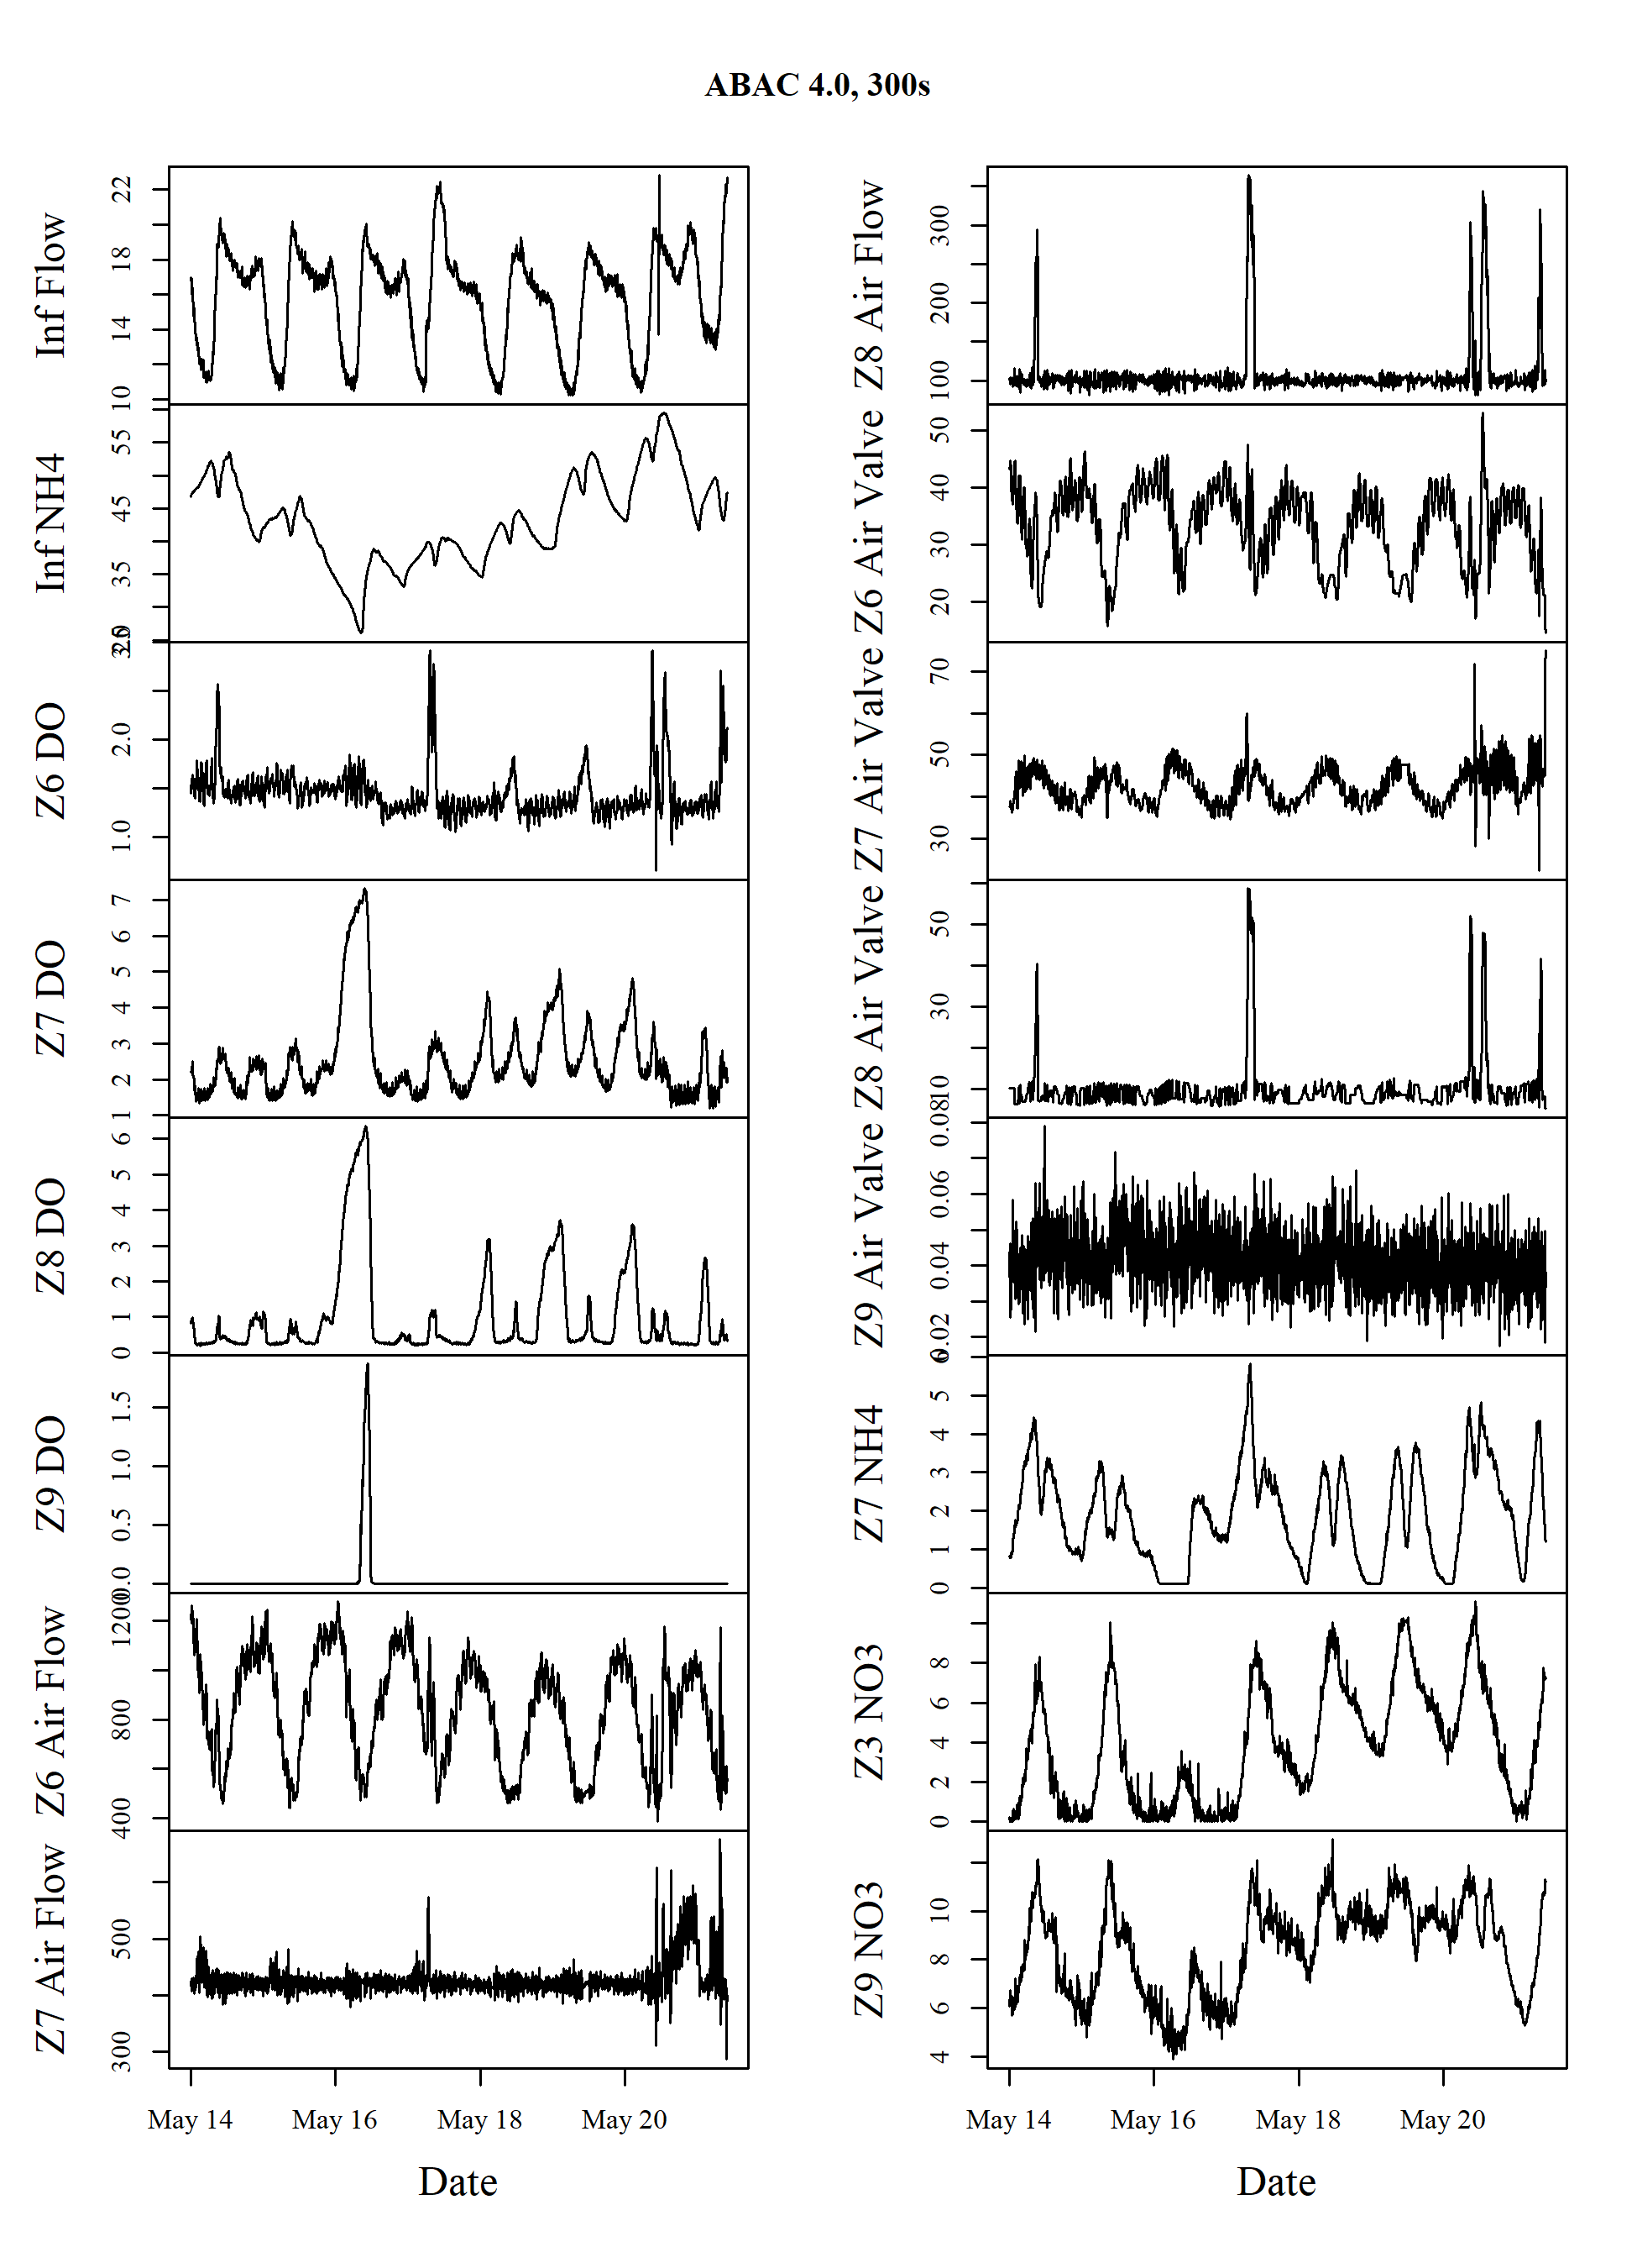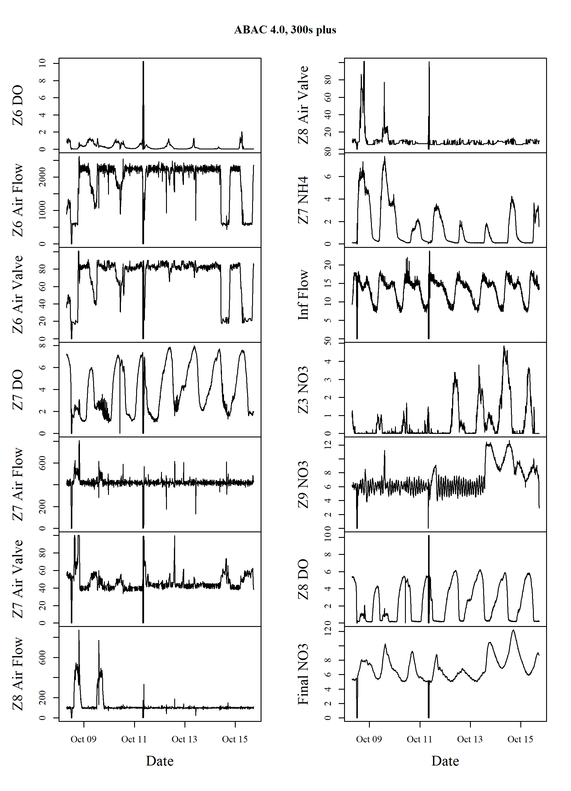

Brosilow, Coleman, and Babu Joseph. 2002. “Techniques of Model-Based Control.” In. Prentice Hall Professional.

Burger, Gillian, Cole Sigmon, Christopher Marks, Conor Tyler, Christopher Bye, Daniela Conidi, and Kevan Brian. 2019. “Modeling Aeration Performance for Energy Reduction.” In *Proceedings of the Water Environment Federation*. Vol. 2019.

Duffy, Gregory, Steven Kestel, Matthew Gray, George Lee, Tilo Stahl, and Jim Zhang. 2010. “Dissolved Oxygen Control Based on Real Time Oxygen Uptake Rate Estimation.” *Proceedings of the Water Environment Federation* 2010 (8): 7400–7408.

Environmental Protection Agency), USEPA (US. 2011. “Working in Partnership with States to Address Phosphorus and Nitrogen Pollution Through Use of a Framework for State Nutrient Reductions.” Office of Water, US Environmental Protection Agency Washington, DC. <https://www.epa.gov/sites/production/files/documents/memo_nitrogen_framework.pdf>.

James, Gareth, Daniela Witten, Trevor Hastie, and Robert Tibshirani. 2013. *An Introduction to Statistical Learning*. Vol. 112. Springer.

Rieger, Leiv, Richard Jones, Peter Dold, and Charles Bott. 2012. “Myths About Ammonia Feedforward Aeration Control.” In *Proceedings of the Water Environment Federation*. Vol. 2012. <https://doi.org/10.2175/193864712811726392>.

Visioli, Antonio. 2006. *Practical Pid Control*. Springer Science & Business Media.